PREPARED FOR CG UNITED INSURANCE  Build Your Future  Licensing & Ongoing Services Proposal  Prepared by White Owl Solutions, August 4, 2026 | 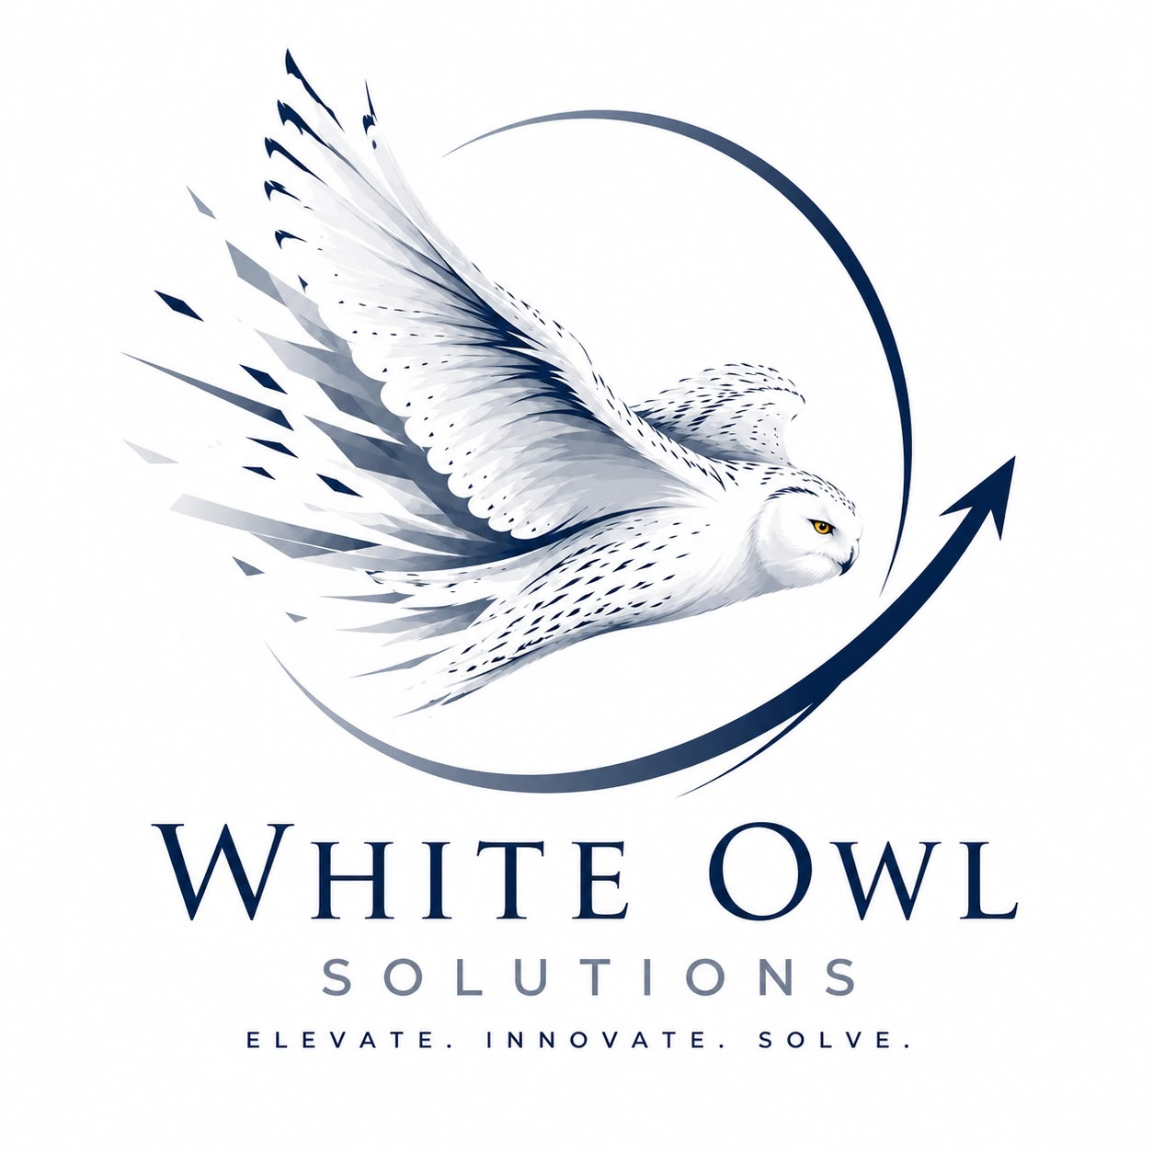

Build Your Future was built specifically for CG United, and the results from Expo 2026 show it worked. This proposal covers how CG United can keep using the platform, for future events or for other projects across the business.
71  Plays at Expo 2026 | 60  Unique Leads Captured | 2  Event Days

Executive Summary
Build Your Future ran at Expo 2026 and generated 71 plays and 60 unique leads over two days. CG United now has the opportunity to keep the platform and use it again, whether for future events or other projects.

Investment Summary
Item | Investment
Platform Rights and Handover (one time) | US$11,400
Production Hardening | US$1,300
Production Hardening Plus | US$2,200
Configuration and Deployment Preparation (base fee)* | US$900
Installation and Logistics (indicative)** | US$320 to US$1,900
*Base fee. The final scope may vary depending on the deployment. See Scope and Investment for details.
**Indicative range by location, from Kingston to international. The final cost depends on the specific deployment.
RECOMMENDED INITIAL PACKAGE
Platform Rights and Handover + Production Hardening Plus: US$13,600
This option gets the platform ready for regular use, with the extra tools and training CG United's team needs to manage it confidently.

What CG United Receives
- Permanent rights to use the platform across CG United's events, markets, and other projects, with no annual renewal fee
- The production source code built for CG United, including the application, configuration files, and build scripts, along with CG United's branding, content, and deployment documentation
- The right to commission future changes to the platform, with White Owl Solutions remaining CG United's preferred technical and implementation partner

Scope and Investment
Platform Rights and Handover: US$11,400
This is a one time, fixed fee that gives CG United permanent rights to use the platform. It is paid according to the schedule under Payment Structure, not as a single upfront payment.
Production Hardening: US$1,300
- Fixes for known reliability issues
- More consistent leaderboard and session behavior
- Better display fit across devices
- Browser compatibility testing
- Simple startup and shutdown instructions
- Basic documentation for the team
Production Hardening Plus: US$2,200
Includes everything above, plus:
- Wider testing across devices
- A simple admin screen so CG United's team can view session data, export leaderboard results, and restart activations without help from White Owl Solutions
- Lead and score export
- A way to recover a session if something goes wrong
- A training walkthrough for staff
- Support right after handover while the team gets comfortable using it
Configuration and Deployment Preparation: US$900 base fee
This covers the routine changes needed to prepare the platform for a new use, whether that is another event, staff training, a campaign, or a different kind of activity. Work can include updating copy and content, adjusting approved branding, changing screens or settings, and updating questions, scoring, or other configurable details.
It also includes testing on one agreed device, one QA session, up to two rounds of revisions, and remote support for up to 8 hours during the agreed deployment window, during standard business hours. Where relevant, White Owl Solutions can export the resulting user or activity data once the deployment is complete.
The base fee covers routine changes within the existing platform. Larger changes, new functionality, integrations, or work that needs substantial development will be scoped and quoted separately before work begins.
Installation and Logistics: indicative estimates, quoted per deployment
- Kingston and nearby: US$320 to US$570
- Other Jamaican parishes: US$500 to US$950
- Caribbean and international technical labor: US$950 to US$1,900, not including travel and other costs
This covers setup on site, staff orientation, and testing. For international deployments, White Owl Solutions either travels directly, with expenses covered by CG United, or arranges a vetted local technician who is subcontracted through White Owl Solutions.

Data and User Records
CG United owns the user and activity data generated through the platform. Returning users are identified by their email address, so repeat visits do not create duplicate records. Each individual session keeps its own result, whether that is a game score or another kind of outcome.
White Owl Solutions can provide data exports in an agreed format after each deployment. CG United approves all consent and privacy language shown to users.

Key Terms
- CG United has 10 business days after delivery to complete acceptance testing.
- The 30 day warranty period begins once CG United accepts the platform, or automatically if no defects are reported within that window. It covers defect correction at no extra charge. New features or changes to what was agreed are quoted separately.
- All fees are quoted in US dollars. Hardware, travel, venue charges, third party services, taxes, and other pass-through costs are not included unless specifically listed in an approved quotation.
Payment Structure
- Platform Rights and Handover: 50% on approval, 50% following delivery and acceptance
- Production Hardening: 50% before work begins, 50% on delivery
- Configuration and Deployment Preparation: paid in full before work begins
- Installation and Travel: a deposit and any approved costs are paid before the deployment, with final reconciliation afterward where necessary

Next Steps
- Confirm the preferred Production Hardening option
- Approve the commercial proposal
- White Owl Solutions prepares the final agreement and implementation schedule
Once the proposal is approved, White Owl Solutions will prepare the final agreement and confirm the implementation schedule.

